Parent Power


Addition Algorithm Strategies

Dear Parents,
3rd grade has been working on adding 3-digit numbers. We are teaching our students to have a deeper understanding of numbers so you may see some strategies that are unfamiliar. The following are some examples of the strategies we will be using this year. Please encourage your child to use these strategies instead of the traditional strategies even though we will use that strategy later.
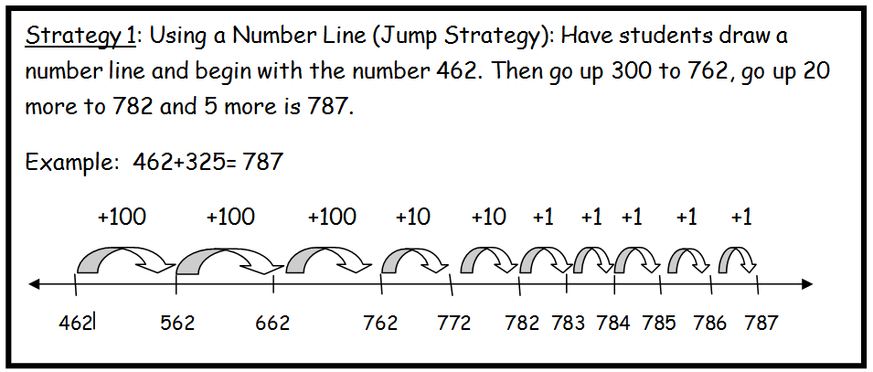
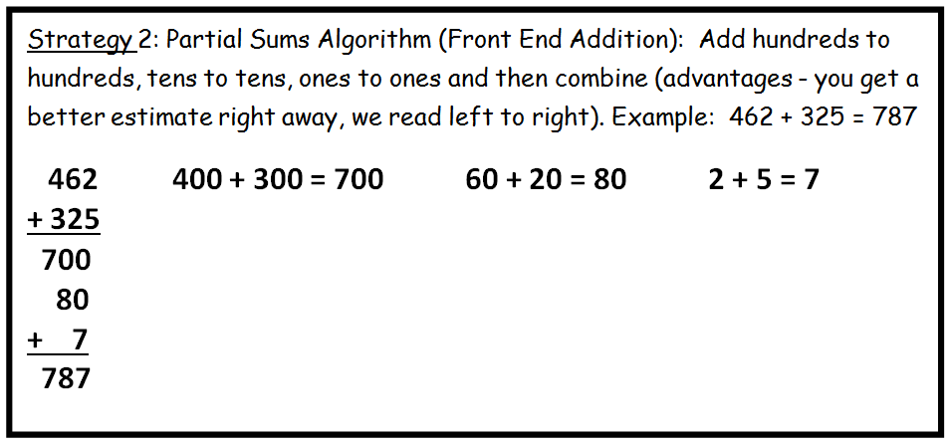
Skills covered in this unit include (review from 2nd grade):
- Place value (ones, tens, hundreds), addition with and without regrouping, subtraction with and without regrouping, and the relationship between addition and subtraction.

