Parent Power


Subtraction Algorithm Strategies

Parents,
3rd grade is beginning a unit on subtracting 3 digit numbers. We are teaching our students to deeper understand numbers so you may see some strategies that may be unfamiliar. Following are some examples of the strategies we will be using this year. Please encourage your student to use these strategies instead of the traditional strategy that we grew up with.
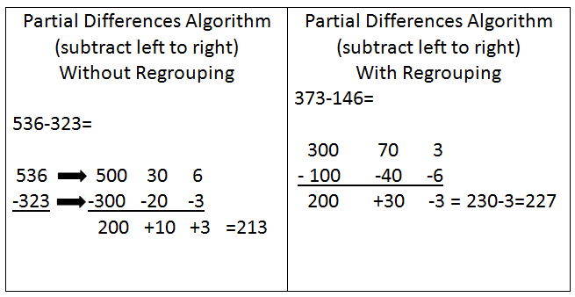
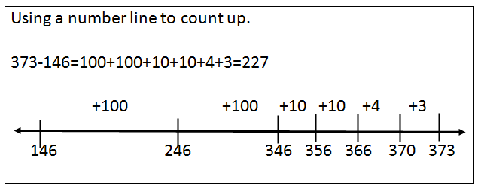
Skills covered in this unit include (review from 2nd grade):
- Place value (ones, tens, hundreds), addition with and without regrouping, subtraction with and without regrouping, and the relationship between addition and subtraction.

